**Experiment No: Date:**

**PARAMETERS OF AC CIRCUITS Aim:**

To find the Average, RMS values of AC sinusoidal signal. To find the average power, apparent power, reactive power and power factor for an AC circuit. Simulate the circuits with single elements R, L, C and combination of RLC.

**Components Required:**

AC voltage source, volt meter, Ammeter, Scope, RLC series Branch, Display, Powergui(continuous), Power Measurement, RMS Measurement.

**Theory:**

**Average and RMS values**

* Waveforms of voltage and current that vary periodically with time may be characterized by their average value or their root mean square (rms) value. The latter is used to determine the power supplied, dissipated, or stored by a circuit element. Some of the measuring instruments you will use respond to average values of voltage or current, while others respond to rms values.

**Measurements of AC signal:**

* Amplitude is a non-negative scalar measure of a wave’s maximum magnitude of oscillation. In electrical engineering it may be thought of as the maximum absolute value reached by a voltage or current waveform as measured from the Center of the oscillation. An amplitude measurement may be reported as peak, peak-to-peak, average, or RMS.
* Peak amplitude is the height of an AC waveform as measured from the center of the oscillation to the highest positive or lowest negative point on a graph. Also known as the crest amplitude of a wave.
* Peak-to-peak amplitude is the total height of an AC waveform as measured from maximum positive to minimum negative peaks (the highest peak to the lowest valley) on a graph of the waveform. Often abbreviated as “P-P”, e.g., Vp-p or Vpp
* Average value is the arithmetic “mean” of a waveform’s values over one cycle. The average value of any waveform with equal-area portions above and below the “zero” line on a graph is zero. However, often as a practical measure of amplitude, a waveform may be characterized by its average absolute value, calculated as the arithmetic mean of the absolute values of the waveform.
* “RMS” stands for Root Mean Square, and is a way of expressing an AC quantity of voltage or current in terms functionally equivalent to DC. For example, 10 volts AC RMS is the amount of AC voltage that would produce the same amount of heat dissipation across a resistor of given value as a 10 volt DC power supply. Also known as the “equivalent” or “DC equivalent” value of an AC voltage or current.

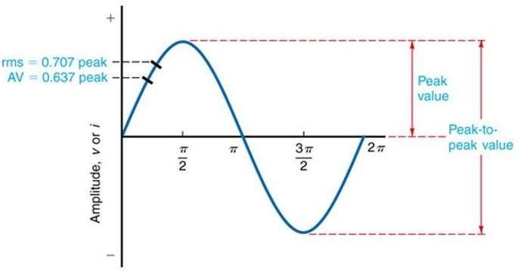

Figure. Measurements of AC Signal

**Active Power**

The power which is actually consumed or utilized in an AC Circuit is called **True power** or **Active power** or **Real power**. It is measured in kilowatt (kW) or MW. It is the actual outcomes of the electrical system which runs the electric circuits or load.

𝑃 = 𝑉rms 𝐼rms cos 𝜃

**Power Factor**

In a purely resistive circuit, the current is in phase with the applied voltage, whereas in a purely inductive and capacitive circuit the current is 90 degrees out of phase, i.e., if the inductive load is connected in the circuit the current lags voltage by 90 degrees and if the capacitive load is connected the current leads the voltage by 90 degrees. The angle between voltage and current waveform is known as phase angle. Cos of the phase angle gives the power factor. It can be

also

**Reactive Power**

It has been seen that power is consumed only in resistance. A pure inductor and a pure capacitor do not consume any power since in a half cycle whatever power is received from the source by these components, the same power is returned to the source. This power which returns and flows in both the direction in the circuit, is called Reactive power. This reactive power does not perform any useful work in the circuit.

The reactive power is measured in kilo volt-ampere reactive (KVAR) or MVAR.

𝑄 = 𝑉rms 𝐼rms sin 𝜃

**Apparent Power**

**Definition:** The product of root mean square (RMS) value of voltage and current is known as **Apparent Power**. This power is measured in KVA or

MVA.

𝑆 = 𝑉rms 𝐼rms

**Power Factor**

In a purely resistive circuit, the current is in phase with the applied voltage, whereas in a purely inductive and capacitive circuit the current is 90 degrees out of phase, i.e., if the inductive load is connected in the circuit the current lags voltage by 90 degrees and if the capacitive load is connected the current leads the voltage by 90 degrees. The angle between voltage and current waveform is known as phase angle. Cos of the phase angle gives the power factor. It can be calculate as follows

Power Factor= Active power/Apparent Power

**Procedure:**

**(a) R circuit:**

**1.**Connect theAC voltage source with resistor with required voltage and frequency

**2.**Connect voltage Measurement and current Measurement.

**(b) L circuit:**

**1.** Connect theAC voltage source to pure inductor.

**2.**Initialize the values.

**3.**Simulates the model.

**(c) C circuit:**

**1.** Connect theAC voltage source to pure capacitor.

**2.**Give very small amount of capacitor.

**3.**Analyze the model.

**(d) RC circuit:**

**1.**Connect theAC voltage source with resistor and capacitor.

**2.** Initialize the values of resistance and capacitance.

**3.**Analyze the model.

**(e) RL circuit:**

**1.**Connect theAC voltage source with resistor and inductor.

**2.**Check the values.

**(f) RLC circuit:**

**1.**Create a circuit consisting of resistor, capacitor and inductor of particular values.

**2.**Analyze and check values.**Tabular column**

**(a)R-circuit**

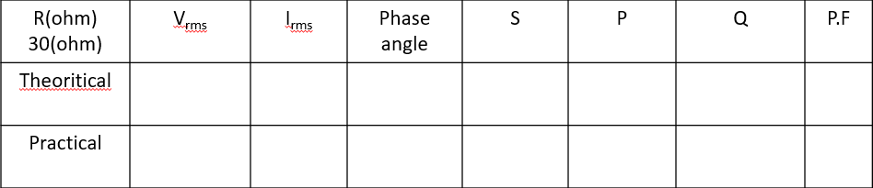

**(b)L-circuit**

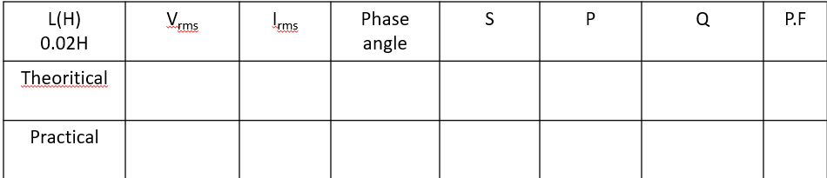

**(c)C-circuit**

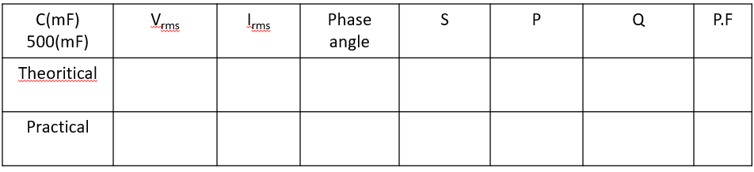

**(d)RC-circuit**

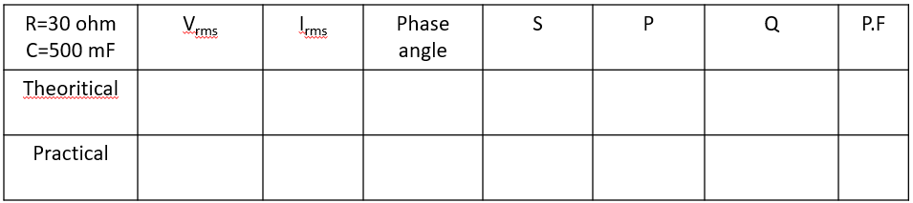

**(e)RL-circuit**

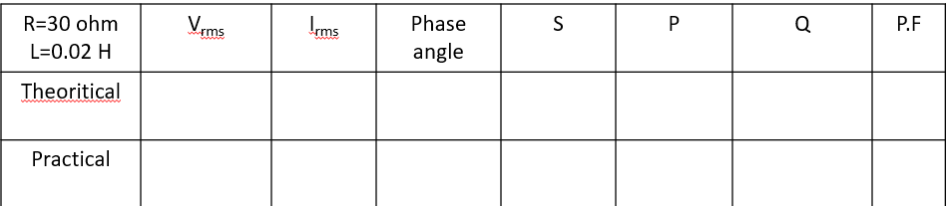

**(f)RLC-circuit**

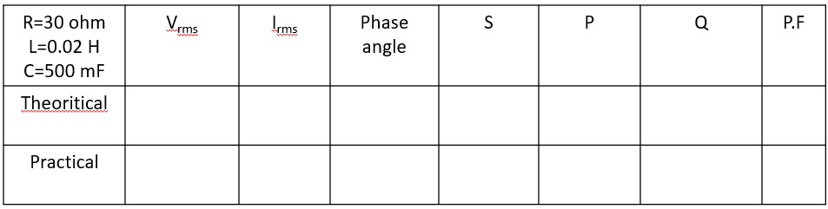

**Simulink Graphs**

**R-circuit:**

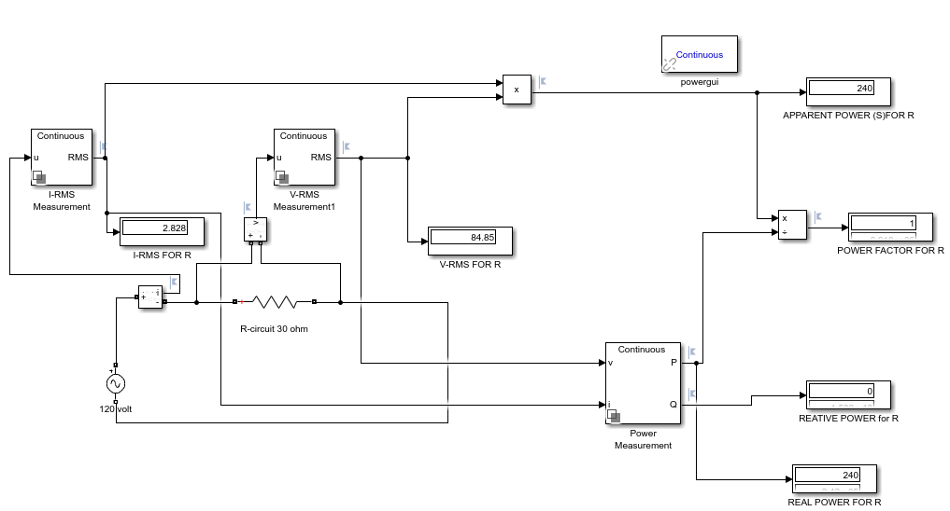

**L-circuit:**

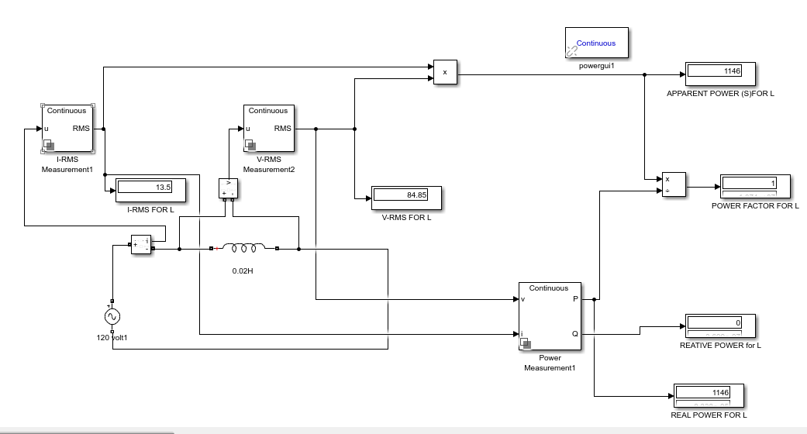

**C – circuit:**

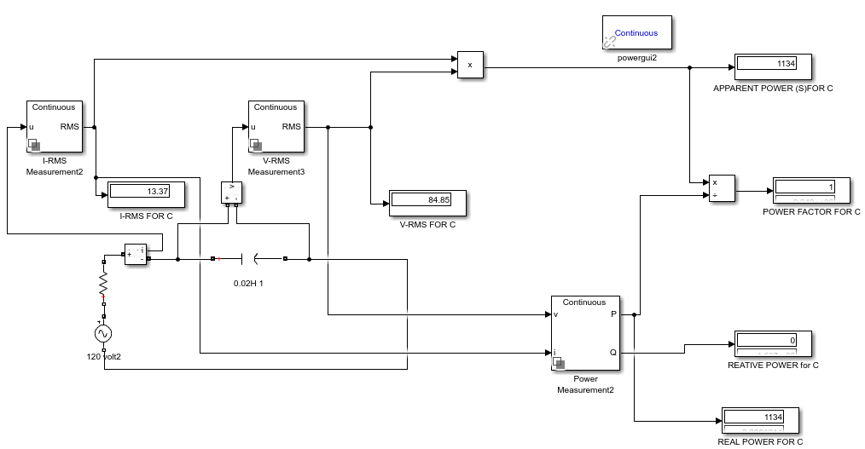

**RL-circuit:**

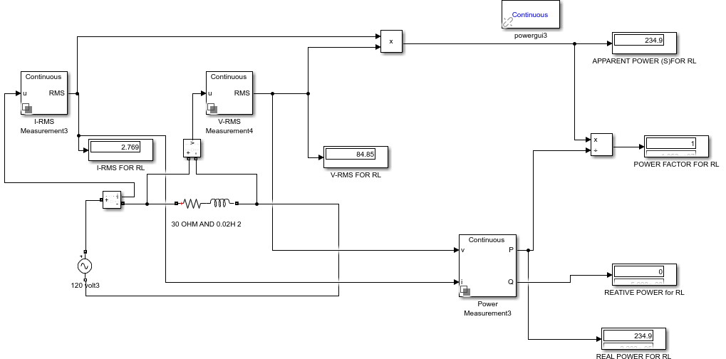

**RC – circuit:**

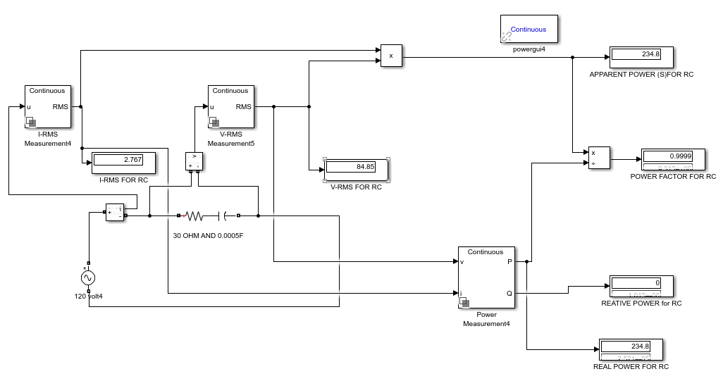

**RLC – circuit:**

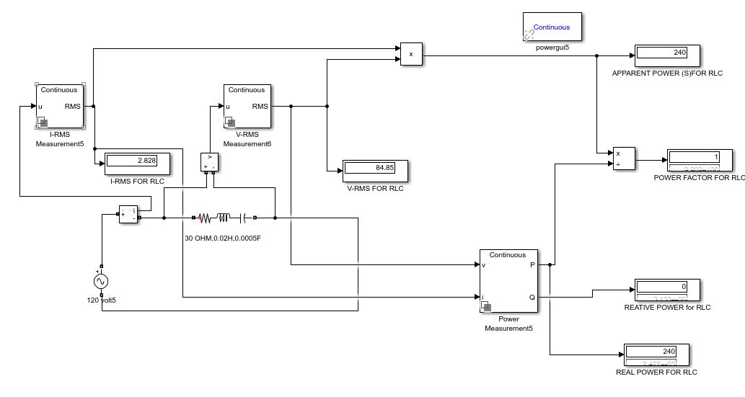

**Results & Inference:**

The average values rms values, apparent power, Real power, and Reactive Power are same for both theory and practical.

Simulation is done and calculated the parameters of AC circuit.

In pure resistor, voltage and current are in same phase.

In pure inductor, current lags voltage by 900.

In pure capacitor, current leads voltage by 900.